##### ZC ReplaceOperation Procedure

##### Overview

In brief, the replacement process involves extracting the essential PAN information from the original ZC through the CLI, and then setting all these information into the new ZC via the CLI. To simplify manual operations, serial tool and Python scripts are used to complete the CLI input.

##### I. Network Information Backup

1: Input the following command in primaryzc CLI: ***zb_dump_pan_info***,

2: Manually save the printed information as a txt document "***nwkInfo.txt***".

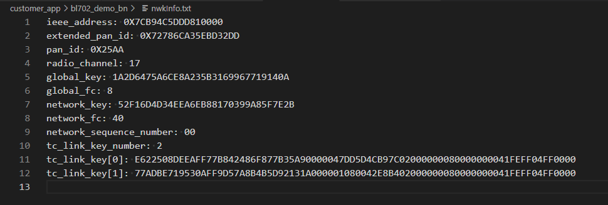

3: Connect to a new zc using SecureCRT to execute the script **Restore_PAN.py.**

**II. User Data Backup**

All user data (stored in Easyflash) should be cloned by the user themselves, and the operation process can refer to step I.